Tourism, culture, recreation

Name of the investment project | «KU the Nikolaev zoo. New construction of a complex for large ungulates at the address: Sq. M. Leontovych, 1 in Mykolayiv »
Name of enterprise (organization) | Municipal institution of the Nikolaev city council the Nikolaev zoo
Details of the enterprise (organization)  mailing address  Phone | р / рах. UA248201720344381001100042429 GUDKSU in Kyiv  54003 Mykolaiv, Sq. Nikolai Leontovich, building 1  (0512) 55-60-45
Ownership | municipal institution
Share of state ownership (%) | -
The head of the enterprise (organization):  Position  Last name, patronymic  Head's phone | Director  Topchiy Volodymyr Mykolayovych  (0512) 57-18-99
Contact person for the investment project:  Position  Last name, patronymic  Phone | Director  Topchiy Volodymyr Mykolayovych  (0512) 57-18-99
General description of the enterprise: | The total area of ​​KU Mykolayiv Zoo is 18.4813 hectares;  Existing buildings: 36-capital buildings, 1-exhibition pavilion; 25 aviaries; 3-rate; 78 other buildings.  General condition of buildings: the buildings need major repairs.
Characteristics / description of the enterprise | The main tasks of the institution:  - exhibition, preservation and reproduction in artificial conditions of animals, primarily endangered, rare, listed in the Red Book of Ukraine and the international Red Lists.
The main products of the enterprise (list of goods and services) | - carrying out educational and cultural-educational work in the field of ecology, nature protection, zoology and animal husbandry;  - conducting mass environmental events;  - organization of leisure for children and adults, creating conditions to meet the needs of the population.
Location features | KU The Nikolaev zoo is in the center of the city of Nikolaev, in a place convenient for visiting.
Availability of communications | Convenient transport routes, entrances.  There is a telephone connection and the Internet.
Electrification, gasification, water and drainage | Available
The authorized capital of the enterprise | -
Number of employees | 230
Market position | The best zoo in Ukraine, a member of WAZA - the World Association of Zoos and Aquariums, a sight of Nikolaev
Short-term and long-term plans of the enterprise | Construction of new and capital repairs of existing enclosures, preservation of rare and endangered species.
The essence of the investment project | The aim of the project is the possibility of exhibiting new species of animals, attracting a large number of visitors
The level of readiness of the investment project | In 2017, LLC "Autograph-N" developed estimate documentation for the construction of a complex for large ungulates and the Branch of SE "UKRDERZHBUDEKSPERTIZA" in the Mykolaiv region submitted an Expert Report №15-0710-17 (15-0370-17) dated 29.11.2017. concerning consideration of design documentation on the working project «KU the Nikolaev zoo. New construction of a complex for large ungulates at the address: Sq. M. Leontovych, 1 in Mykolayiv »
Total required investments (thousands of US dollars), including:  - invested own funds;  - the need for investment funds | -  546,237891 thousand US dollars
Targeted use of investment funds | Investments will be directed to the construction of summer enclosures "Island of Animals" and the construction of a complex for large ungulates
The method of attracting investment | Direct investment
Brief justification of the feasibility of the project | Development of tourist activity and resort business (implementation of a complex of measures for development of local infrastructure, tourist business.
Payback period of the project (years) | 10 years
Number of jobs created | -
Photo materials (if available) | -

Name of the investment project | Mini-golf in the Children's Town "Fairy Tale"
Name of enterprise (organization) | Budget institution of the Nikolaev city council Cultural and game complex Children's fairy tale town
Details of the enterprise (organization)  mailing address  Phone | 54017,  Mykolayiv, street Decembrists 38-a,  (0512) 47-65-53
The head of the enterprise  (organizations):  Position  Full Name  Head's phone | Director  Dymchyshyna Natalia Oleksandrivna  (0512) 47-65-53
Contact person for the investment project:  Position  Last name, first name and patronymic  Phone | Director  Dymchyshyna Natalia Oleksandrivna  (0512) 47-65-53
General description of the enterprise: | Cultural and play complex "Children's Town" Fairy Tale "occupies a land area of ​​2.54 hectares, which is transferred to the institution on the right of permanent use. There are 13 entertainment facilities and more than 100 children's attractions. The general condition of the buildings is satisfactory.
Characteristics / description of the enterprise | The main tasks of the institution:  - creating conditions to meet the cultural needs of the population, especially children;  - organization of leisure for children and adults, creating conditions for the restoration of physical strength, communication of children;  - support of socially important, culturally - creative, cognitive - entertaining, sports - improving, art - aesthetic initiatives;  - introduction of innovative forms of leisure organization in accordance with the needs of the population, especially children.
The main products of the enterprise  (list of goods and services) | Children's game programs, cultural events
Location features | Children's town "Fairy Tale" is located in the city center on the street. Decembrists. In fact, it occupies the inter-street quarter. Has access to the street: Decembrists, Lyagina, Dunaeva, lane. Shipbuilders
Availability of communications | Telephone, Internet available
Electrification, gasification, water and drainage | Available
Number of employees | 18
Turnover of goods, robots and services | -
Market position | -
Short-term and long-term plans of the enterprise | Introduction of innovative forms of children's recreation
The essence of the investment project | The aim of the project is to introduce a dynamic, sporty mini-golf game for children and adolescents, aimed at promoting health by installing Mini-golf equipment in the park.
The level of readiness of the investment project | Investment proposal
Total required investments (thousands of US dollars), including:  - invested own funds;  - the need for investment funds | 8.5 thousand dollars USA  -  8,5,0 thousand dollars USA
Targeted use of investment funds | Purchase of equipment and inventory
The method of attracting investment | Grant cats; own funds; investors' funds; other sources are not prohibited by current legislation.
Brief justification of the feasibility of the project | Mini-golf is a sport that is not only a form of recreation and entertainment among adults, but also an officially recognized sport. It is a sport that is practiced and watched by millions of people around the world. This is a very bright, healthy activity that helps to find new friends, as well as promotes the development of the potential of children with disabilities, forms a culture of healthy and safe lifestyle. The main task of the project is to preserve and strengthen the health of children.
Payback period of the project (years) | -
Number of jobs created | -
Photo materials | 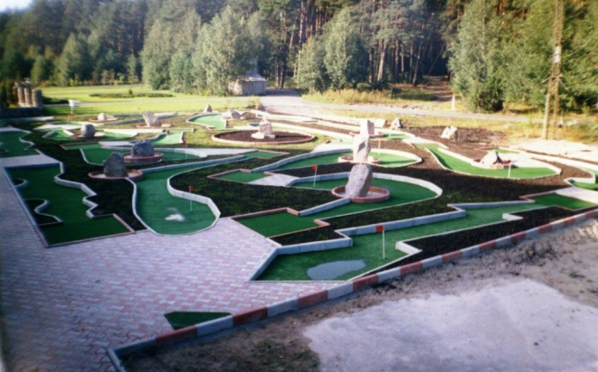

Name of the investment project | Light and music fountain in the Children's Town "Fairy Tale"
Name of enterprise (organization) | Budgetary institution of the Nikolaev city council Cultural - game complex Children's fairy tale town
Details of the enterprise (organization)  mailing address  Phone | 54017,  Mykolayiv, street Decembrists, 38-a,  (0512) 47-65-53
The head of the enterprise (organization):  Position  Last name, first name and patronymic  Head's phone | Director  Dymchyshyna Natalia Oleksandrivna  (0512) 47-65-53
Contact person for the investment project:  Position  Last name, first name and patronymic  Phone | Director  Dymchyshyna Natalia Oleksandrivna  (0512) 47-65-53
General description of the enterprise: | Cultural and play complex "Children's town" Fairy Tale "occupies a plot of land with an area of ​​2.54 hectares, which is transferred to the institution on the right of permanent use. There are 14 entertainment facilities and more than 100 children's attractions. The general condition of the buildings is satisfactory.
Characteristics / description of the enterprise | The main tasks of the institution:  - creating conditions to meet the cultural needs of the population, especially children;  - organization of leisure for children and adults, creation of conditions for recovery of physical forces, communication of children;  - support of socially important, culturally - creative, cognitive - entertaining, sports - improving, art - aesthetic initiatives;  - introduction of innovative forms of leisure organization in accordance with the needs of the population, especially children.
The main products of the enterprise  (list of goods and services) | Children's game programs, cultural events
Location features | Children's town "Fairy Tale" is located in the city center on the street. Decembrists. In fact, it occupies the inter-street quarter. Has access to the street: Decembrists, Lyagina, Dunaeva, lane. Shipbuilders
Availability of communications | Telephone, Internet available
Electrification, gasification, water and drainage | Available
Number of employees | 18
Turnover of goods, robots and services | -
Market position | -
Short-term and long-term plans of the enterprise | Introduction of innovative forms of children's recreation
The essence of the investment project | The aim of the project is to create a harmonious water picture with musical accompaniment, with lighting and water movement for family recreation and even more attractive for visitors and tourists.
The level of readiness of the investment project | Investment proposal
Total required investments (thousands of US dollars), including:  - invested own funds;  - the need for investment funds | 170.0 thousand dollars USA  -  170.0 thousand dollars USA
Targeted use of investment funds | Design and survey works, expertise, repair works and payment to contractors, sketch project, payment of copyright and other non-property rights for musical accompaniment and creation of own musical accompaniment, purchase of materials and equipment, visual wages for workers of the town who took part in creating investment project.
The method of attracting investment | Grant cats; own funds; investors' funds; other sources are not prohibited by current legislation.
Brief justification of the feasibility of the project | Children's town "Fairy Tale" is the central object of our city for family recreation, which is also visited by tourists from around the world.  The main task of the project is to create the first light and music fountain in the city for the general attractiveness, attraction of tourists, even greater comfort and variety for family rest, both the city of Nikolaev, and the Children's town "Fairy tale".
Payback period of the project (years) | -
Number of jobs created | -
Photo materials | 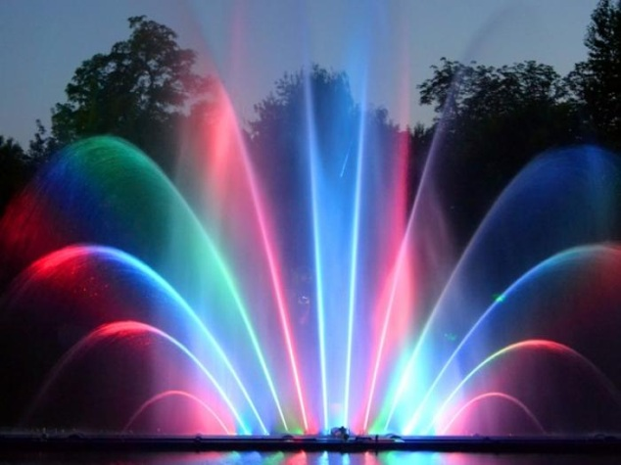

Name of the investment project | "Test Tower"
Name of enterprise (organization) | Budgetary institution of the Nikolaev city council Cultural - game complex Children's fairy tale town
Details of the enterprise (organization)  mailing address  Phone | 54017,  Mykolayiv, street Decembrists, 38-a,  (0512) 47-65-53
The head of the enterprise (organization): | Director  Dymchyshyna Natalia Oleksandrivna  (0512) 47-65-53
Contact person for the investment project: | Director  Dymchyshyna Natalia Oleksandrivna  (0512) 47-65-53
General description of the enterprise: | Cultural and play complex "Children's town" Fairy Tale "occupies a plot of land with an area of ​​2.54 hectares, which is transferred to the institution on the right of permanent use. There are 14 entertainment facilities and more than 100 children's attractions. The general condition of the buildings is satisfactory.
Characteristics / description of the enterprise | The main tasks of the institution:  - creating conditions to meet the cultural needs of the population, especially children;  - organization of leisure for children and adults, creation of conditions for recovery of physical forces, communication of children;  - support of socially important, culturally - creative, cognitive - entertaining, sports - improving, art - aesthetic initiatives;  - introduction of innovative forms of leisure organization in accordance with the needs of the population, especially children.
The main products of the enterprise  (list of goods and services) | Children's game programs, cultural events
Location features | Children's town "Fairy Tale" is located in the city center on the street. Decembrists. In fact, it occupies the inter-street quarter. Has access to the street: Decembrists, Lyagina, Dunaeva, lane. Shipbuilders
Availability of communications | Telephone, Internet available
Electrification, gasification, water and drainage | Available
Number of employees | 18
Turnover of goods, robots and services | -
Market position | -
Short-term and long-term plans of the enterprise | Introduction of innovative forms of children's recreation
The essence of the investment project | The aim of the project is to create an attraction-quest, which will organize high-quality family leisure, stimulate the younger generation to real communication, team spirit, sports development, development of logical thinking. This attraction is recommended for children with autism, as well as antisocial children and adolescents.
The level of readiness of the investment project | Investment proposal
Total required investments (thousands of US dollars), including:  - invested own funds;  - the need for investment funds | 80.0 thousand dollars USA  -  80.0 thousand dollars USA
Targeted use of investment funds | Project - survey works, examination, sketch project, repair works and salaries of builders, works on reconstruction of premises, purchase of materials and equipment, visual salary for workers of the town who took part in creation of the investment project.
The method of attracting investment | Grant cats; own funds; investors' funds; other sources are not prohibited by current legislation.
Brief justification of the feasibility of the project | 1. Creating an interactive attraction - a quest that will organize quality family leisure, encourage children and adolescents to real communication, develop teamwork skills, organize innovative leisure for children and adolescents: orphans deprived of parental care, as well as children from large families. 2. Creating an attraction - a quest for sports development of the younger generation.  3. Creating an exciting, modern interactive attraction - a quest, will take children out of the virtual world of computer games in real 3-D adventures, exciting tests that will have to pass to achieve the goal.4. Creating an attraction - a quest, which is not only fun but also a simulator for children and adults. Visiting the attraction is recommended for children with autism, children with developmental delays, as well as antisocial children and adolescents to develop logical and intellectual thinking, the ability to achieve mutual understanding and coherence, working in a team to achieve a common goal.5. Creation of the first attraction in the region - a quest for attraction of tourists, increase of comfort and variety for family rest, both Nikolaev, and the Children's town "Fairy tale".
Payback period of the project (years) | -
Number of jobs created | -
Photo materials | 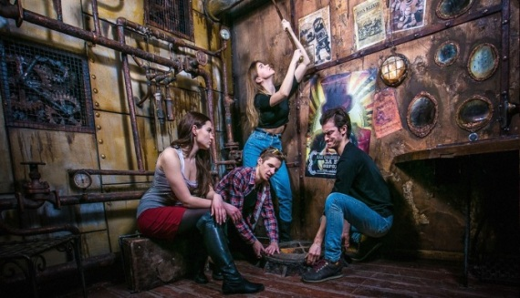  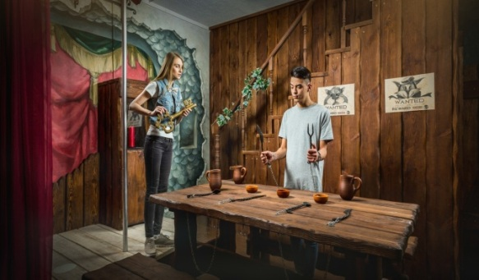

Name of the investment project | "Transition to LED outdoor and indoor lighting of the Children's Town" Fairy Tale "
Name of enterprise (organization) | Budgetary institution of the Nikolaev city council Cultural - game complex Children's fairy tale town
Details of the enterprise (organization)  mailing address  Phone | 54017,  Mykolayiv, street Decembrists, 38-a,  (0512) 47-65-53
The head of the enterprise (organization): | Director  Dymchyshyna Natalia Oleksandrivna  (0512) 47-65-53
Contact person: | Director  Dymchyshyna Natalia Oleksandrivna  (0512) 47-65-53
General description of the enterprise: | Cultural and play complex "Children's town" Fairy Tale "occupies a plot of land with an area of ​​2.54 hectares, which is transferred to the institution on the right of permanent use. There are 14 entertainment facilities and more than 100 children's attractions. The general condition of the buildings is satisfactory.
Characteristics / description of the enterprise | The main tasks of the institution:  - creating conditions to meet the cultural needs of the population, especially children;  - organization of leisure for children and adults, creation of conditions for recovery of physical forces, communication of children;  - support of socially important, culturally - creative, cognitive - entertaining, sports - improving, art - aesthetic initiatives;  - introduction of innovative forms of leisure organization in accordance with the needs of the population, especially children.
The main products of the enterprise  (list of goods and services) | Children's game programs, cultural events
Location features | Children's town "Fairy Tale" is located in the city center on the street. Decembrists. In fact, it occupies the inter-street quarter. Has access to the street: Decembrists, Lyagina, Dunaeva, lane. Shipbuilders
Availability of communications | Telephone, Internet available
Electrification, gasification, water and drainage | Available
Number of employees | 18
Turnover of goods, robots and services | -
Market position | -
Short-term and long-term plans of the enterprise | Introduction of innovative forms of children's recreation. Landscaping to attract visitors.
The essence of the investment project | The aim of the project is full artistic lighting not only of the town, but also of some objects and interiors, giving visitors the opportunity to see in the evening and appreciate all the beauty and mastery of fine arts created by talented artists of our city and greenery.
The level of readiness of the investment project | 50%
Total required investments (thousands of US dollars), including:  - invested own funds:  - need for investment funds: | 31.0 thousand dollars USA  11.0 thousand dollars USA  20.0 thousand dollars USA
Targeted use of investment funds | Purchase and installation of the latest lighting equipment and artistic lighting.
The method of attracting investment | Grant cats; own funds; investors' funds; other sources are not prohibited by current legislation.
Brief justification of the feasibility of the project | Children's town "Fairy Tale" is the central object of our city, which is loved not only by children but also by adults and visitors from around the world. Events of various levels are held in the town both in the daytime and in the evening. The territory of the Children's Town needs full economic lighting to provide visitors with an opportunity to see in the evening and appreciate all the beauty and skill of fine arts, created by talented artists of our city. The implementation of this project will significantly reduce the cost of electricity consumption, increase the reliability and durability of lighting fixtures, as well as help create architectural lighting for the Children's Town "Fairy Tale".
Payback period of the project (years) | -
Number of jobs created | -
Photo materials | 