Social - infrastructure projects

Name of the investment project | Reconstruction - restoration of a non-residential building (BOF) on the street. Artillery, 7 near the Nikolaev city palace of culture and arts
Name of enterprise (organization) | Nikolaev city palace of culture and arts
Details of the enterprise (organization):  mailing address  Phone | 54030, Mykolaiv region, Mykolaiv, 7 Artillery Street  37-04-26
Ownership | Communal
Share of state ownership (%) | -
The head of the enterprise (organization):  Position  Last name, first name and patronymic  Head's phone | Director  Boychuk Sergey Mikhailovich  +38 (0512) 37-04-26, 093 378 33 14
Contact person for the investment project:  Position  Last name, first name and patronymic  Phone | Chief Accountant  Myakhkova Olena Yevheniivna  (0512) 37-04-26  (093) 527-33-95, ngdki@ukr.net
General description of the enterprise: | Plot area - 12738.38 m2 ;, building area - 1237.38 m2; total area - 2229.31 m2; construction volume - 12502.20 m2.  BOF building, summer cinema, summer playground.
Characteristics / description of the enterprise | Meeting the needs of city residents in amateur art and other amateur creative initiatives, creating conditions for their leisure and recreation, implementation of state, regional and city policy in the field of culture
The main products of the enterprise  (list of goods and services) | Providing services for the organization and technical support of events of different levels, status and activities
Location features | Within the settlement
Availability of communications | Transport routes (entrances)
Electrification, gasification, water and drainage | Availability of electrification, water and drainage, but needs major repairs and restoration.
Statutory fund
Number of employees | 16
Market position | Market share of these goods, works, services; availability and level of competition, etc.
Short-term and long-term plans of the enterprise | Trends and prospects of development, improvement of existing processes, development of new technologies, development of new types of products (works, services), expansion of markets, etc.
The essence of the investment project | Creation of a modern center of culture and leisure of the city with the use of innovative technologies
The level of readiness of the investment project | The project is at the stage of investment proposal. There is no project documentation.
Total required investments (thousands of US dollars), including:  - invested own funds:  - the need for investment funds: | The total amount of required investments is about 10,000,000 dollars. USA (approximately), including:  - own funds are not invested due to the small amount of general and special funds;  - development of project documentation - 100 000 dollars. USA (approximately);  - construction and restoration works in the House of Fleet Officers - $ 9,900,000. USA (approximately).
Targeted use of investment funds | Restoration of the building and purchase of modern media equipment
The method of attracting investment | Direct investment
Brief justification of the feasibility of the project | The project is appropriate because it will help preserve the unique architectural, cultural and historical monument of urban planning (over 197 years since its inception)
Payback period of the project (years) | At this stage of development it is difficult to predict
Number of jobs created | After the complete reconstruction, approximately 50 jobs will be created, regardless of the number of existing ones.
Photo materials

Name of the investment project | Dwelling house construction:  street Oleg Olzhich, 5-B, "Building - 30"
Name of enterprise (organization) | PE MZhK "Vitovka"
Details of the enterprise (organization):  - mailing address  - phone | 54052, Mykolayiv,  street Leningradskaya 5-in room 5  (0512) 24-61-96
Ownership | Non-state property
Share of state ownership (%) | 0
The head of the enterprise (organization)  - position  - Full Name  - phone number of the head | Agent  Kid Victor Anatolyevich
Contact person for the investment project:  Position  Last name, first name and patronymic  Head's phone | Director of the Nikolaev regional management of State youth housing  Fedoronchuk Vasily Mikhailovich  +38 050 552 55 25
General description of the enterprise | -
Characteristics / description of the enterprise | Construction of residential and non-residential buildings
The main products of the enterprise | Housing construction
Location features | Ship district of Nikolaev, the developed infrastructure, nearby there is a house of culture, a swimming pool "Aquarius"
Availability of communications | Near the house
Electrification, gasification, water and drainage | Electricity, water supply and sewerage networks are connected nearby
The authorized capital of the enterprise | UAH 100,000.0
Number of employees | 10
Market position | Unfinished construction
Short-term and long-term plans of the enterprise | Housing construction and commissioning
The essence of the investment project | Construction of a multi-storey residential building
The level of readiness of the investment project | 15%
The total amount of required investments (thousand US dollars), including:  - invested own funds  - the need for investment funds | 3518,519  48.0  3470,519
Method of attracting investments (what amounts and from what sources it is planned to attract) | Credit resources according to state and local housing programs
Targeted use of investment funds | Housing construction
Brief justification of the feasibility of the project, the social effect of implementation | Providing housing for citizens of different categories
Payback period of the project | -
Number of jobs created | 45
Photo materials | 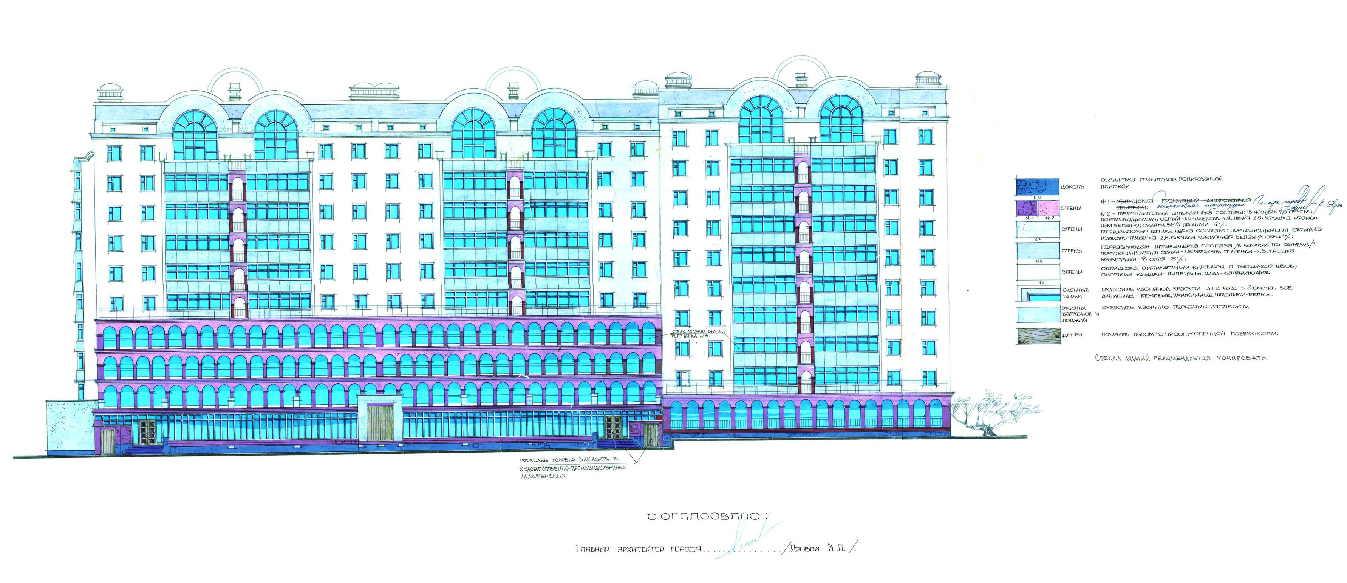

Name of the investment project | Construction of a residential building "New construction. Buildings of the residential district "Northern" of the Central district of the city of Nikolaev. Multi-storey residential building of the building 27b-II turn »
Name of enterprise (organization) | LLC MZhK "Nikolaevmolodbud"
Details of the enterprise (organization):  - mailing address  - phone | Mykolayiv, street Bug Boulevard 13/4  0512 37 77 43, 67 04 78
Ownership | Non-state property
Share of state ownership (%) | 0
The head of the enterprise (organization)  - position  - Full Name  - phone number of the head | director  Furdalenko Alexander Nikolaevich  0512 67 04 78
Contact person for the investment project:  Position  Last name, first name and patronymic  Head's phone | director of the Nikolaev regional management of State youth housing  Fedoronchuk Vasily Mikhailovich  +38 050 552 55 25
General description of the enterprise | LLC MZhK "Nikolaevmolodbud" is created in 2000 for the purpose of the decision of housing problems of young citizens, young families by their own work, employment of youth by creation of workplaces, industrial and civil construction, capital repairs (reconstruction) of houses and constructions.
Characteristics / description of the enterprise | Construction of residential and non-residential buildings
The main products of the enterprise | Residential buildings
Location features | The central district of the city with a developed transport infrastructure, near many shops of various profiles, the market "North", secondary schools, a supermarket, as well as within walking distance of the river Ingul
Availability of communications | Near the house
Electrification, gasification, water and drainage | All networks pass near the house
The authorized capital of the enterprise | 88 632,00 hryvnias
Number of employees | 25
Market position | Unfinished construction
Short-term and long-term plans of the enterprise | Commissioning of the house under construction and construction of the next house
The essence of the investment project | Construction of a multi-storey residential building
The level of readiness of the investment project | 33%
The total amount of required investments (thousand US dollars), including:  - invested own funds  - the need for investment funds | 4259,259  952,353  3306,906
Method of attracting investments (what amounts and from what sources it is planned to attract) | National budget  The budget of Nikolaev  Citizens' own funds
Targeted use of investment funds | Construction of residential buildings
Brief justification of the feasibility of the project, the social effect of implementation | Providing housing for citizens of various categories in need of better living conditions, including young families, ATO / OOS participants and internally displaced persons
Payback period of the project | -
Number of jobs created | 45
Photo materials | 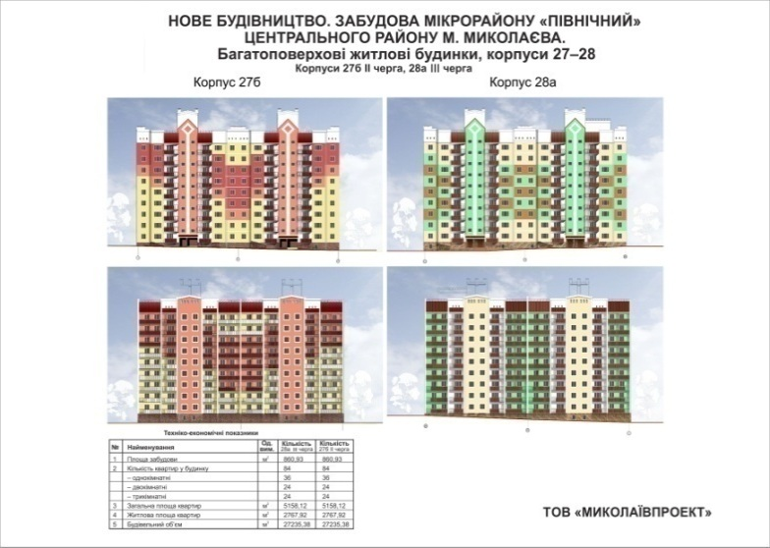

Name of the investment project | New construction of the Ice Palace
Name of the initiator of the investment project | Department of physical culture and sports of the Nikolaev city council
Contact person for the investment project | Management of capital construction of the Nikolaev city council
Brief description of the company's history (if available) | Local government
The essence of the project is concise | Creating appropriate conditions for the development of physical culture and sports by creating a multifunctional facility.
Territory that the project will have an impact on | Mykolayiv
The population to which the project will apply | 483.5 thousand people
Description of the problem to be solved by the project | Lack of a multi-functional facility in the city for various sports, including winter.
Expected quantitative and qualitative results from the project implementation, project innovation | According to the preliminary design, it is planned to build an Ice Palace with a field of 30x60 m and grandstands for 1,000 seats, an arena.
The main activities of the project | Development of design and estimate documentation.  Construction of a two-storey building, on the ground floor of which it is planned to place an arena with twelve locker rooms and gyms, and on the second floor - fan shops and cafes.
Project implementation period (from (month / year) - to (month / year) | 15 months
Volume of project financing, thousand UAH | 180,000.0
Sources of project funding | Attracted funds of investors, funds are not prohibited by current legislation
Project participants and their functions | Executive bodies of the Nikolaev city council, the interested organizations, the enterprises, the organizations.
Other project information (if required) | - the period of implementation is determined approximately, will be finally determined after the manufacture of PKD  - the amount of funding is tentatively determined, will be finally determined after the production of PKD
The area that will be affected by the project | Mykolayiv
Photo materials | 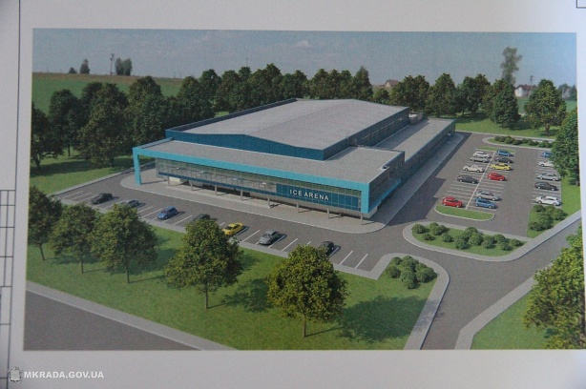

Name of the investment project | New construction of a swimming pool at the address: Heroes of Ukraine Ave., 2/4 in Nikolaev
Name of the initiator of the investment project | Department of physical culture and sports of the Nikolaev city council
Contact person for the investment project | Management of capital construction of the Nikolaev city council
Brief description of the company's history (if available) | Local government
The essence of the project is concise | Creating appropriate conditions for the development of physical culture and sports by creating a multifunctional facility.
The area that will be affected by the project | Mykolayiv
The population to which the project will apply | 201 thousand people
Description of the problem to be solved by the project | Lack of a multifunctional facility in the city for various sports.
Expected quantitative and qualitative results from the project implementation, project innovation | Swimming pool - 25 m on 8 lanes, small pool - 11 m. on 3 tracks, 3-storey premises
The main activities of the project | Development of design and estimate documentation.  1st floor - locker rooms, toilets and utility rooms; 11th floor - game halls, gyms, spectator stands 450 seats, dining room, conference hall; 111 floor coaching offices, medical, administrative offices and rest rooms.
Project implementation period (from (month / year) - to (month / year) | Two years
Volume of project financing, thousand UAH | 70 000.0
Sources of project funding | Attracted funds of investors, funds are not prohibited by current legislation
Project participants and their functions | Executive bodies of the Nikolaev city council, the interested organizations, the enterprises, the organizations.
Other project information (if required) | - the period of implementation is determined approximately, will be finally determined after the manufacture of PKD  - the amount of funding is tentatively determined, will be finally determined after the production of PKD
The area that will be affected by the project | Mykolayiv
Photo materials | 