Industry, research, innovation and infrastructure projects

Name of the investment project | Creation of an industrial park in the city of Nikolaev
Name of enterprise (organization) | The Nikolaev city council
Details of the enterprise (organization):  mailing address  Phone | Mykolayiv
The head of the enterprise (organization):  Position  Last name, first name and patronymic  Head's phone | Mayor  Senkevich Alexander Fedorovich  +38 (0512) 37-39-17
Contact person for the investment project:  Position  Phone | Alekseev Vladimir Alexandrovich  Acting director of the department of energy, energy saving and introduction of innovative technologies of the Nikolaev city council  +38 (0512) 37-10-70;  ecenter.mk@gmail.com
Location features | Mykolayiv
The essence of the investment project | Creation in Nikolaev of industrial park which purpose is attraction of investments in economy of the city of Nikolaev, development of the industry, attraction of scientific potential for production of innovative production, increase of social standards of living.  The tasks of creating an industrial park are:  - creation of new production facilities on the basis of innovative technologies with a high level of competitiveness;  - creating a favorable investment climate;  - reducing unemployment, creating new jobs;  - effective use of the industrial territory of the city of Nikolaev;  - saturation of the market with new domestic competitive products;  - formation of mechanisms of effective satisfaction of demand of investors on the platforms prepared for placement of objects of innovative sphere, the industry, logistics and the accompanying service, increase of quality of life of the population.
The level of readiness of the investment project | 1. The land plot is allocated - on July 17, 2018 №40 / 13 "About the statement of the project of the land management concerning assignment of the land plot on the Ship area of ​​Nikolaev".  2. Created an industrial park - July 17, 2018 №40 / 10 "On the creation of an industrial park" Energy "and approval of the concept of its development."  3. Нby the order of MEDT from 07.11.2018 № 1618 the park is included in the Register of industrial parks of Ukraine.  Today there is a development of design - estimate documentation of expenses for arrangement of the territory.
Total required investments (thousands of US dollars), including:  - invested own funds;  - the need for investment funds | -  The initial stage is $ 8.8 million. USA.
The method of attracting investment | Direct investment or any possible forms of co-financing with the city budget.
Targeted use of investment funds | - Laying communications directly to the locations of potential assets of the participants.  - Landscaping.
Brief justification of the feasibility of the project, the social effect of implementation | -
Payback period of the project | -
Photo materials | 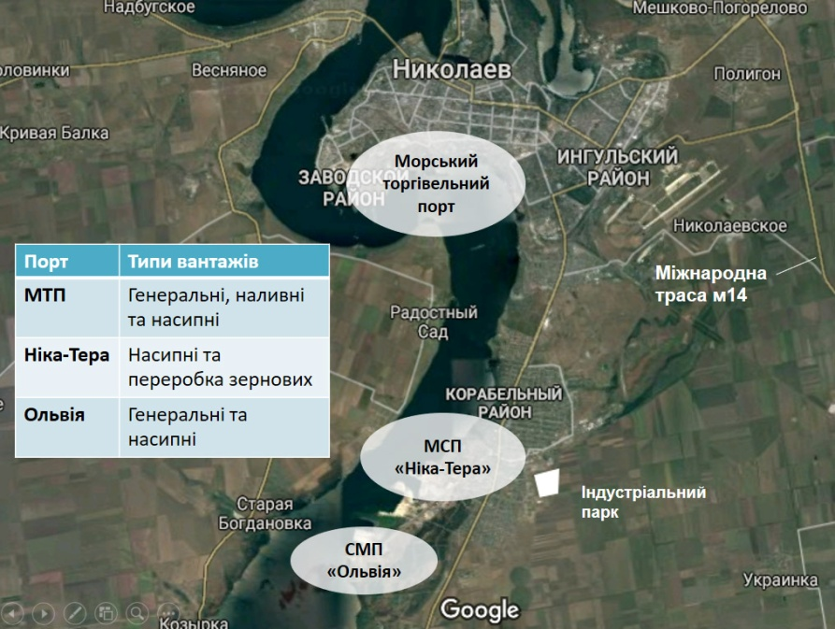  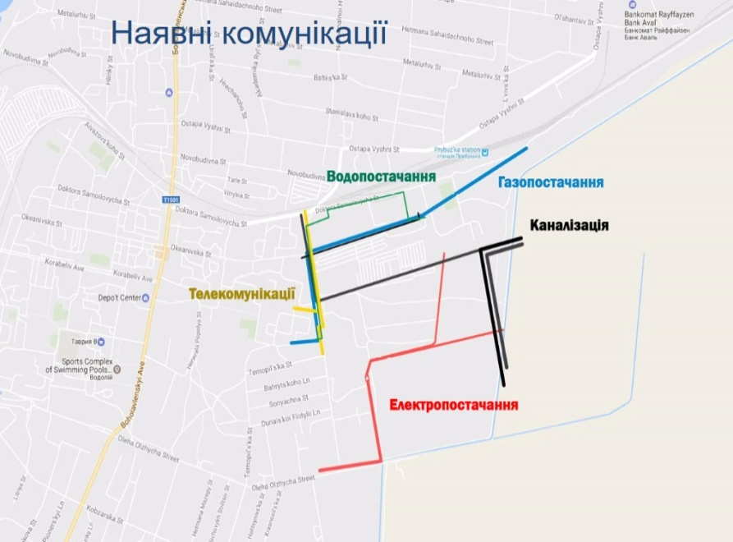  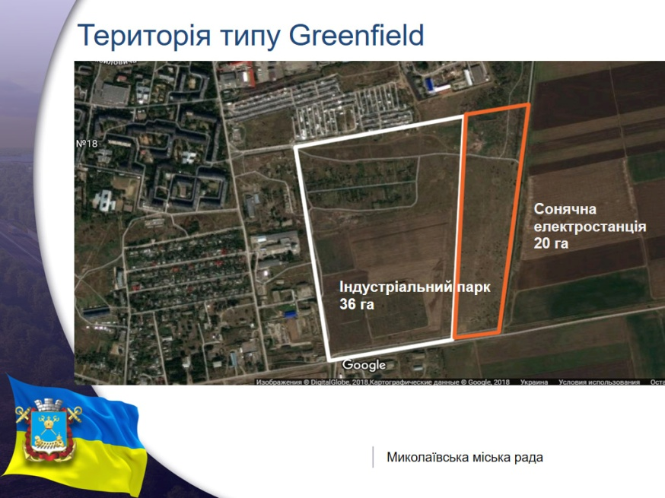  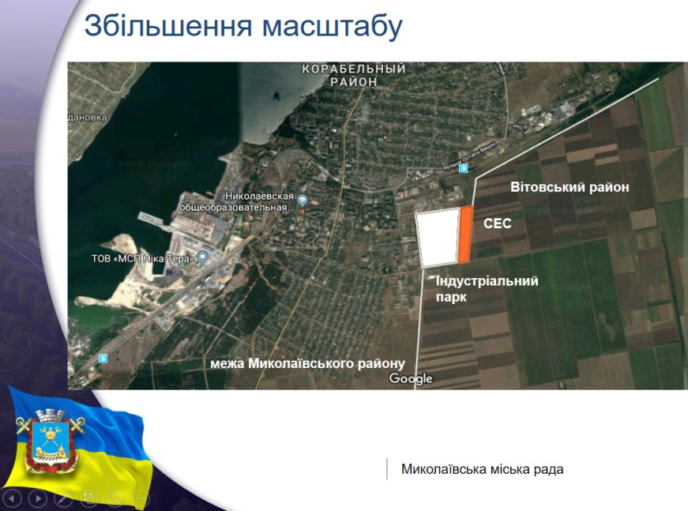

Name of the investment project | "Construction of a base for the accumulation of agricultural products and shipment to seagoing vessels through berth №4, located at: Mykolaiv, st. Aivazovskoho 14 »
Name of enterprise (organization) | Eurovneshtorg LLC
Details of the enterprise (organization): | Legal address: Ukraine, 54010, Mykolayiv, street Morekhidna, 14, office 407  Tel. +38 (0512) 76-68-52
The head of the enterprise (organization): | General Director of Eurovneshtorg LLC  Germanchuk Victor Panasovich
Contact person for the investment project: | Head of the Development and Logistics Department of the Olvia Branch of the State Enterprise AMPU  Nagirna Marina Yuriyivna  Tel. +38 (0512) 67 54 36  Mob. +38 (067) 517 67 63
General description of the enterprise | The main technical and economic indicators of the project: berth № 4 280 m long, two floor storage warehouses with a total volume of 180 thousand tons, 24 silos for storage of 160 thousand tons of grain, grain processing unit for garbage and moisture, auto and railway unloading units, reception grain from barges, conveyor equipment Buhler (Swizerland), two Noero ship loaders with a capacity of 1 thousand tons / h each, the annual volume of grain transshipment - up to 4 million tons.
Characteristics / description of the enterprise | The project envisages the construction of a transshipment complex, which includes a complex of accumulation of goods from rail and road transport with subsequent shipment to sea vessels
The main products of the enterprise (list of goods and services) | Warehousing (basic), rental of water vehicles, sea freight transport, ancillary maintenance of water transport, transport handling of goods
Location features | Eurovneshtorg LLC is located on the territory of SMP Olbia
Availability of communications | +
Electrification, gasification, water and drainage | +
Number of employees | Approximately 140-150 jobs
Turnover of goods, works and services | -
Market position | -
Short-term and long-term plans of the enterprise | The expected volume of cargo processing for 2021 is - 2 million tons.
The essence of the investment project | The project is aimed at developing the seaport, increasing the potential of Ukraine in the export of grain cargo, meeting the economic needs of Ukraine and other participants in world trade
The level of readiness of the investment project | As of now, Eurovneshtorg LLC has completed the second and third stages of the project construction. 24 silos were built, as well as 2 floor storage warehouses for 90 thousand tons each. The terminal can handle up to 200 cars and 300-380 trucks per day.  In 2020, Euronewstorg LLC created 11 new jobs, the total number of employees - 84 people. In turn, the port operator LLC "EVT Grain", which operates in the sea terminal, during 2020 created 30 jobs, the total number of employees - 183 people. In 2021, the companies plan to increase the number of employees by at least 3%.
Total required investments (thousands of US dollars), including: | Own funds were invested - UAH 1 billion 800 million
Targeted use of investment funds | -
The method of attracting investment | Joint financing of the BT Invest, LTD group of companies and Eurovneshtorg LLC
Brief justification of the feasibility of the project | The project is aimed at developing the seaport, increasing the potential of Ukraine in the export of grain cargo, meeting the economic needs of Ukraine and other participants in world trade
Payback period of the project (years) | Approximately 7-8 years
Number of jobs created | Approximately 140-150 jobs
Photo materials | 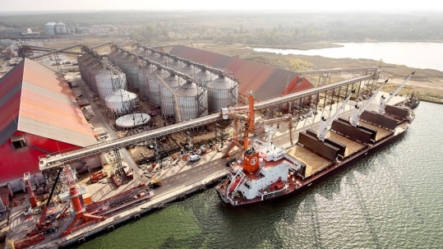  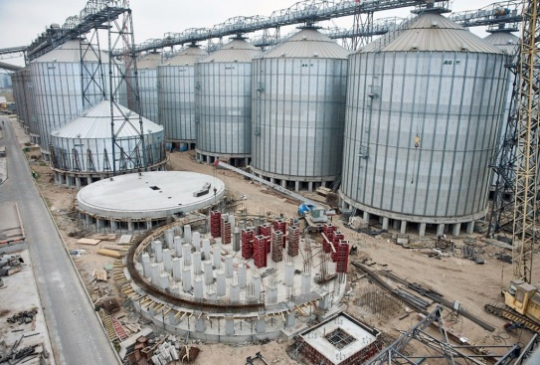

Name of the investment project | Completion and implementation of technological process and electric discharge equipment for restoration and increase of productivity of artesian wells
Name of enterprise (organization) | Institute of Impulse Processes and Technologies of the National Academy of Sciences of Ukraine
Details of the enterprise (organization):  mailing address  Phone | Bogoyavlensky Ave., 43-A, Mykolayiv, 54018, Ukraine  +38 (0512) 55-82-52
The head of the enterprise (organization):  Position  Last name, first name and patronymic  Head's phone | Director  Vovchenko Alexander Ivanovich  +38 (0512) 55-82-52
Contact person for the investment project:  Position  Last name, first name and patronymic  Phone | Lane Science. collaborator, Ph.D.  Petrichenko Sergey Viktorovich  +38 (0512) 58-71-49
General description of the enterprise | The Institute has at its disposal engineering and laboratory and other buildings with sufficient space and appropriate equipment, which are operated in accordance with the main activities of the institution, are in satisfactory condition and are state property.
Characteristics / description of the enterprise | Research of physical and technical aspects of high-voltage pulsed discharge processes in condensed media (first of all, in liquids), creation on their basis of highly efficient environmentally friendly resource- and energy-saving technologies
The main products of the enterprise (list of goods and services) | Development of new electric discharge technologies and creation of the corresponding electrotechnological equipment, research and design works in the field of high-voltage pulse electrical engineering
Location features | The institution is located within the city of Nikolaev, near the railway and transport routes
Availability of communications | There are entrances to the institution, telephone and Internet
Electrification, gasification, water and drainage | In stock
Number of employees | up to 200
Turnover of goods, works and services | Confidential information
Market position | According to its indicators, the development is at the level of world standards
Short-term and long-term plans of the enterprise | Improvement of technological process and equipment, replacement of traditional (inefficient) methods in existing markets (equipment and service)
The essence of the investment project | The essence of the investment project is the completion, manufacture of electric discharge equipment, implementation of a technological process based on the use of high-voltage discharges in the liquid, which leads to compression forces and destruction of various clogging deposits on filters, development of old and new cracks in the rock formation. , and as a result - increase the inflow of water without destroying the filters.
The level of readiness of the investment project | Equipment was manufactured and implemented in wells in Ukraine (Zaporizhia, Ternopil, Mykolaiv regions, Kyiv), Russia, Kazakhstan, China.  Necessary refinement, completion of equipment units (on a modern elemental and material basis) to improve their operational and technological performance.
Total required investments (thousands of US dollars) including:  - invested own funds;  - the need for investment funds | 270.0  about 200.0 (not subject to exact calculation in US dollars);  70.0
Targeted use of investment funds | Completion of equipment and technology (technological regulations) and their mass implementation
The method of attracting investment | Direct investment
Brief justification of the feasibility of the project | During the operation of artesian wells due to contamination of filters and water supply channels there is a reduction and then complete cessation of water access to the well. To restore the productive characteristics of the well requires the use of effective methods to increase the inflow of water into the well. The equipment and technology developed by the institute for electric discharge decompression of artesian, oil and gas wells have been tested for many years in industrial conditions and in comparison with other methods of well treatment differ in technological simplicity, selectivity and processing efficiency, environmental friendliness and relatively low cost.  The experience of using the electric discharge method testifies to the actual restoration of the initial flow rate of wells and the refusal to drill new wells (sufficiently costly approach).
Payback period of the project (years) | Depending on the number of treated wells: from one to two years.
Number of jobs created | -
Photo materials | 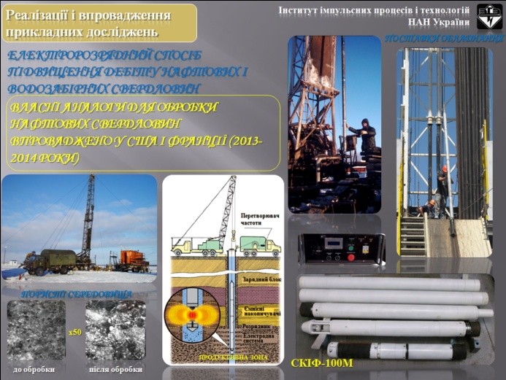

Name of the investment project | Construction of berth № 14a of the seaport of Nikolaev
Name of Company | The Nikolaev branch of the state enterprise "Administration of seaports of Ukraine" (administration of the Nikolaev seaport)  (hereinafter - the Branch)
Details of the enterprise  mailing address  Phone  Email | Ukraine, 54020, Mykolayiv, street Factory, 23  (0512) 50-84-00 fax. (0512) 50-88-07, 50-78-34  mf@nik.uspa.gov.ua
The head of the enterprise  Position, name,  phone | Head of the branch  Melnichenko Mykhailo Anatoliyovych  (0512) 50-84-00
Contact person for the investment project | Head of the Port Infrastructure Development Service  Pirogova Natalia Viktorivna, (0512) 50-84-10  Head of the Department of Engineering Structures and Capital Construction of the Port Infrastructure Development Service  Krivobok Dmytro Ivanovych, (0512) 50-78-50
General description of the enterprise | Mykolaiv Seaport (hereinafter - MPM) is a modern international highly mechanized universal transport hub, specializing in the transshipment of various cargoes, both general and bulk and bulk from land transport to seagoing vessels and vice versa.  The balance of the Branch includes 23 berths, of which 19 berths with a total length of 3,776.8 m are involved in loading and unloading operations. MPM berths are connected to the Black Sea basin by the Buzka-Dniprovsko-Lymansky canal with a length of 44 miles, width of the canal - 100 m, depth - 11.2 m, permissible draft for vessels - 10.3 m.
Characteristics / description of the enterprise | The main functions of the state enterprise "Administration of Seaports of Ukraine" (hereinafter - SE "AMPU") in accordance with the Law of Ukraine of 17.05.2012 № 4709-VI "On Seaports of Ukraine" as amended:  - maintenance and ensuring the efficient use of state property, including modernization, repair, reconstruction and construction of hydraulic structures and other port infrastructure facilities;  - providing services to vessels on the approaches and directly in the seaport for their safe navigation, maneuvering and parking;  - organization and provision of safe operation of state-owned port infrastructure facilities, including hydraulic structures;  - organization and safety of navigation;  - organization of development and implementation of the seaport development plan;  - collection and targeted use of port dues.
The main products of the enterprise (list of goods and services) | The total cargo turnover of MPM in 2017 is 23.5 million tons, in 2018 - 29.9 million tons, in 2019 - 33.4 million tons, in 2020 - 30.1 million tons of cargo (data of the State Enterprise "AMPU").
Location features | Location in close proximity to road and railway infrastructure, inland waterways, connected to the sea by the Bug-Dnieper-Estuary canal.
Availability of communications | There are highways and railways, telephone and Internet. Existing engineering networks: electric, gas, water supply and drainage.
Short-term and long-term plans of the enterprise | The project is included in the Plan of development of the seaport of Nikolaev, approved by the order of SE "AMPU" from 06.03.18 №47 and approved by the Ministry of Infrastructure of Ukraine on 10.07.2018.
The essence of the investment project | The project envisages the construction of a new berth № 14A MPM with an approximate length of up to 240 m by extending the wall of the existing berth №14 to its connection with berth №15, the formation of an operating area with depths at the berth 10.5 m, as well as additional territory.  In the rear of the future berth №14A MPM can be formed an area with an approximate area of ​​not less than 12,500 square meters. m., which can be used to build the infrastructure of transshipment complexes.
Turnover of goods, works and services | Increase in cargo handling capacity by 1 million tons per year
Market position | Specialization of the seaport of Nikolaev - grain cargoes.
The total amount of investment required | Approximately UAH 400 million. (calculated on the basis of available design documentation, the actual cost will be determined after the development of design and estimate documentation).
Brief justification of the feasibility of the project | Construction of a new berth №14A MPM with an approximate length of 240 m by extending the wall of the existing berth №14 to its connection with the berth №15, the formation of an operating area with depths at the berth 10.5 m, as well as additional area of ​​at least 12,500 square meters. m.
Payback period (years) | Approximately within 12-15 years (calculated on the basis of available project documentation, will actually be determined after the development of design and estimate documentation).
Number of jobs created | Approximately 100 jobs (calculated on the basis of available project documentation, will actually be determined after the development of design and estimate documentation).

Name of the investment project | Construction of yacht marinas:  - near the Barbarian Bridge;  - in the Liski-2 residential district of the city of Nikolaev.
Name of the initiator of the investment project | Executive committee of the Nikolaev city council
Details of the initiator of the investment project  mailing address  Phone | 54027, Mykolayiv, street Admiral, 20, tel. (0512) 37-12-32
Contact person for the investment project:  Position  Last name, first name and patronymic  Phone | Mayor  Senkevich Alexander Fedorovich  +38 (0512) 37-20-37;  +38 0512 37 07 18  statist@mkrada.gov.ua
Brief description of the company's history (if available) | Local government
The essence of the project is concise | Construction of a yacht marina near the Varvarivsky Bridge and in the Lesky-2 microdistrict.  Also, it is planned to strengthen the shoreline with a length of almost 2000 meters and deepen the bottom of the river for ships to enter the marina.  The construction of the pier is planned at the location of the existing spit. It is planned to build a hotel for 100 people, which will house a restaurant, bars, shops, spa, consumer services.  The hotel building is adjoined by an indoor boathouse of 1500 m2.  Next to the boathouse there is an outdoor area for storing boats and an equipped ramp  crane for lowering and raising vessels, this area has a fence and is guarded.  On the other side of the hotel building there is a parking lot and a public area with a ramp for the lowering of small vessels from trailers. Landscaping of the territory, arrangement of small playgrounds and sports grounds is provided.  Adjustable traffic is provided along the spit  shipowners and the arrangement of bicycle paths.  At the end of the spit, near the office building  a recreational area for recreation is provided  population, including benches, canopies and pergolas,  placement of art objects, arrangement of descent to water.
 | Construction and development of infrastructure - construction of sheds for storage of yachts and boats; yacht club; hotel; ramp for lowering / raising vessels with a crane; buildings for various purposes; restaurant; cafe; shops, spa, as well as places for storage of boats and parking. Arrangement of a playground, descent to water, benches and canopies, various art objects, etc. are provided.
Brief justification of the feasibility of the project, the social effect (expectations) from the implementation | - attracting significant investments to the city;  - creation of modern competitive river infrastructure;  - increase in tourist flow;  - development of entrepreneurship;  - creation of new jobs;  - increase in revenues to local budgets.
Which tasks in the state, branch and local programs of social and economic development the project concerns | Construction and restoration of infrastructural objects of the city.  Improving the ecological condition of rivers in the city.
The purpose of the investment project | Restore infrastructure, clear the bottom of rivers from silt, equip places for comfortable recreation of citizens and guests of the city, give impetus to the development of small and medium-sized businesses.
Planned investments  incl. the volume is planned for the development and formation of infrastructure during the project implementation | At the stage of determination
Method of attracting investments (what amounts and from what sources it is planned to attract) | Direct investment, partnership
Marketing data (brief) | Restoration of the general cultural environment; protection and preservation of the environment; small and medium business development.
Information about the land plot or object of communal property (if necessary); | -
The method of interaction with the investor after receiving funds | Partnership, lending, etc.
Terms of investment project implementation | -
Number of jobs created | -
List of possible risks of the project (brief) | Political and economic situation in the country
Photo materials | 